|  |  |  |
| --- | --- | --- |
| RISK GAME | 2018 | |
| NAME1 : AHMED MORSY ID:4448 NAME2: HASSAN ELSEOUDY ID:3780 NAME3: NEVINE SAID ID:4500 NAME4: MERNA ZAKARIA ID:4106 | |  |

***RISK GAME:***

Risk is a popular game for major strategy type players. In Risk, the objective is to conquer the world by attacking to acquire territory and defending your own territory from your opponents.

Risk is a turn-based game and is best if played with two to six players. In this assignment, you will be developing an abstract and simple GUI version of the Risk game, but you need to understand the rules of the full version.

**Game’s design:**

Using javafx to design the game.

1) first choose which mode we want 🡪 Playing mode (human Vs. Computer)

Or 🡪 Simulation mode (Computer Vs. Computer).

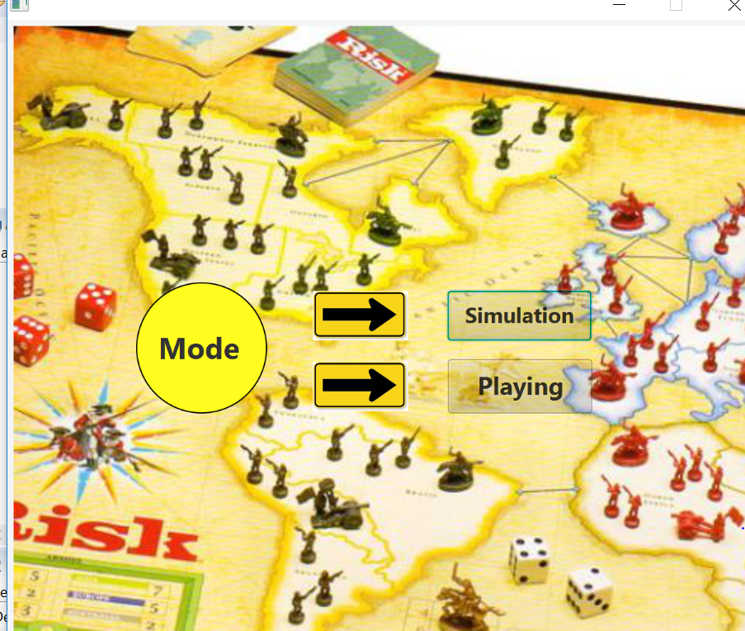

2) Choose the agents you want to play with.

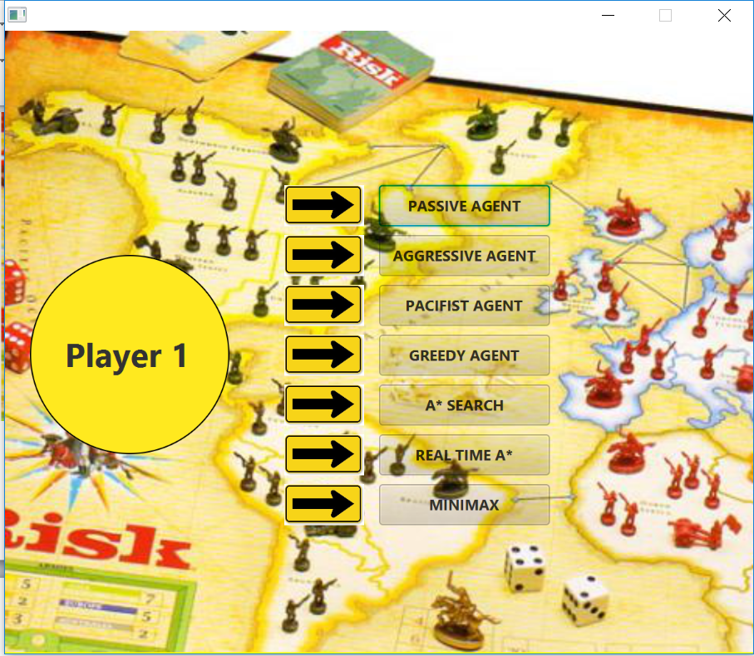

3)Choose which map you want.

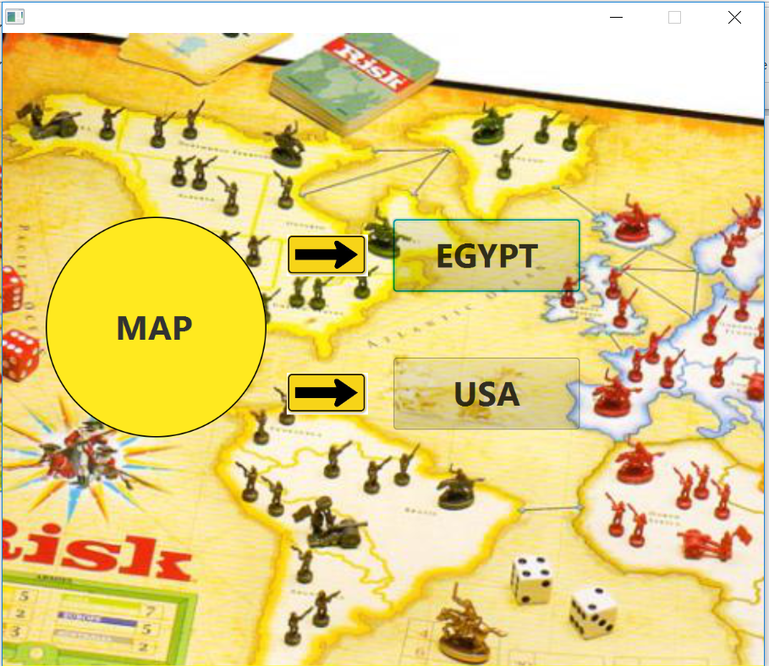

4) Map appears.

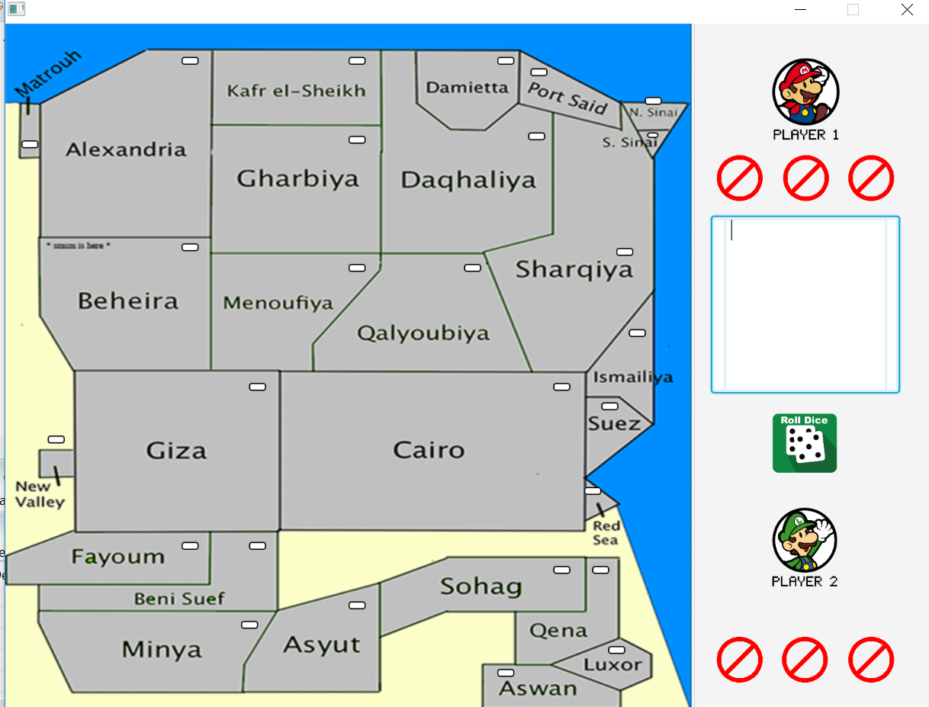

**Agents we use in the game:**

Using Design pattern Factory to easy create objects from our player agents.

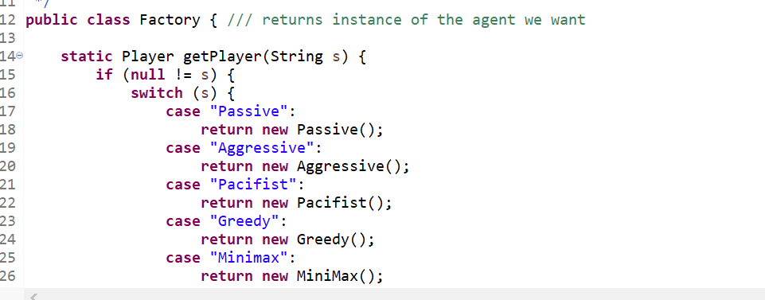

.Using Abstract class called Player to make all the agents follow this class and implement its methods.

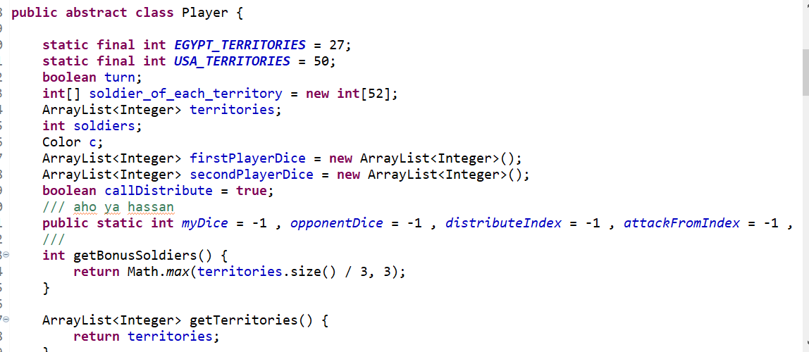

**Passive agent:**

* Distribute_soldiers: distribute bonus armies to fewest armies.

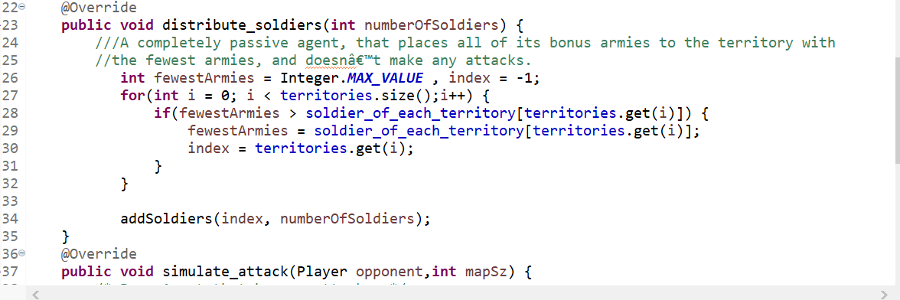

* No attack.

**Aggressive agent:**

🡪Distribute_soldiers: that always places all its bonus armies on the territory with

the most armies.

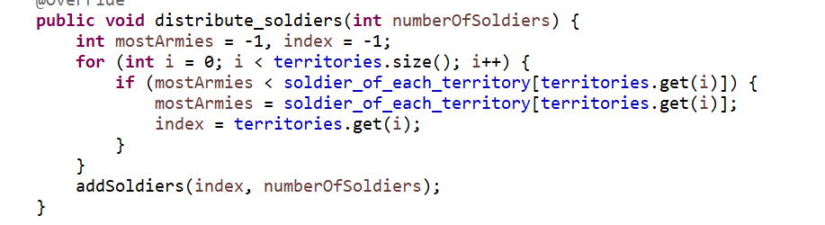

* Simulate_attack: attack territories with most armies that he can attack.

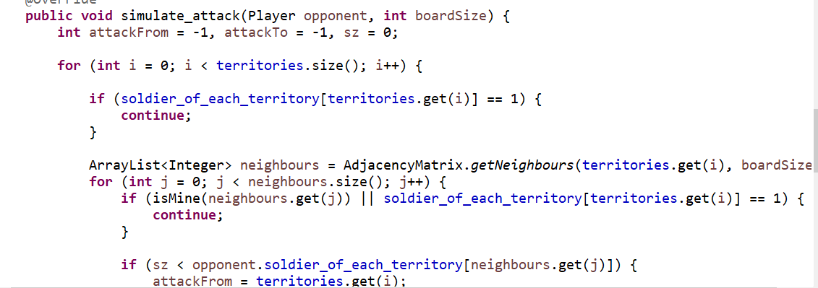

**Pacifist agent:**

🡪Distribute_soldiers: that always places all its bonus armies on the territory with

the most armies.

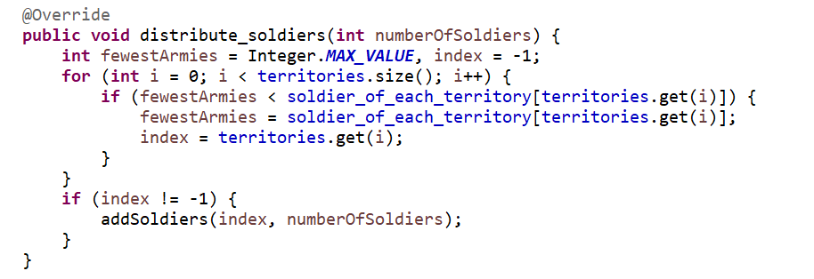

* Simulate_attack: attack one territory with the fewest armies that he can attack.

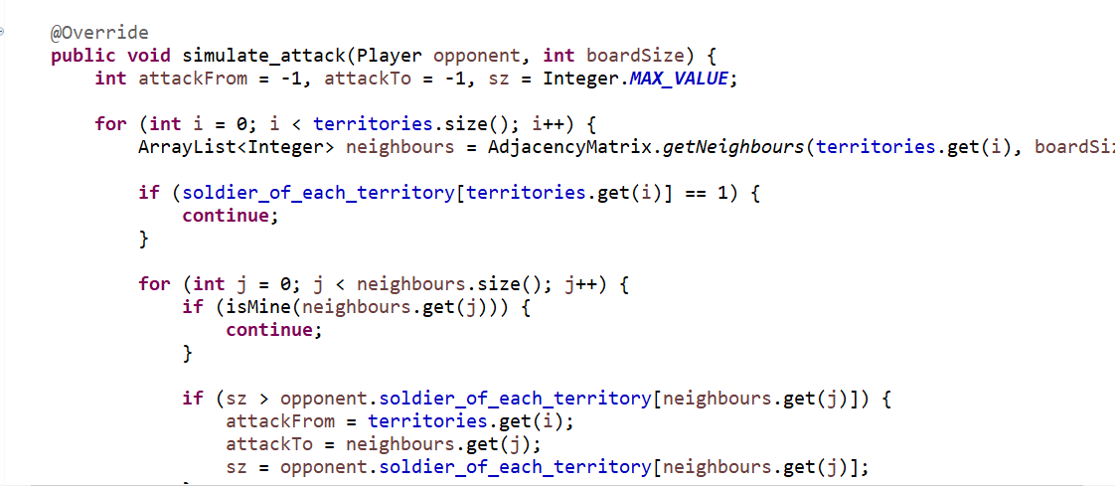

**Greedy agent:**

A greedy agent, that picks the move with best immediate heuristic value.

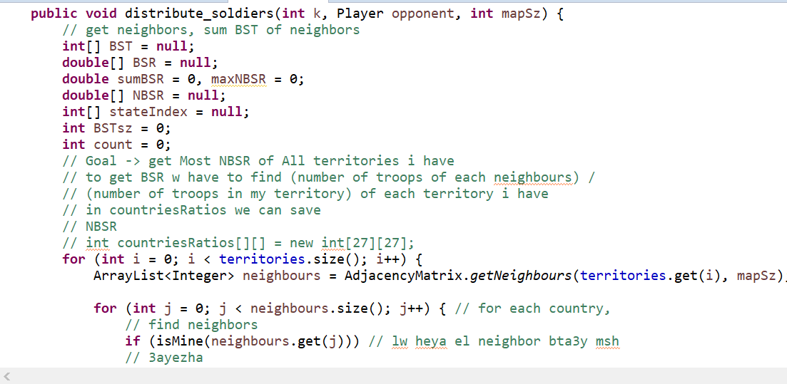

* Using priority queue to get the best state has best Heuristic.

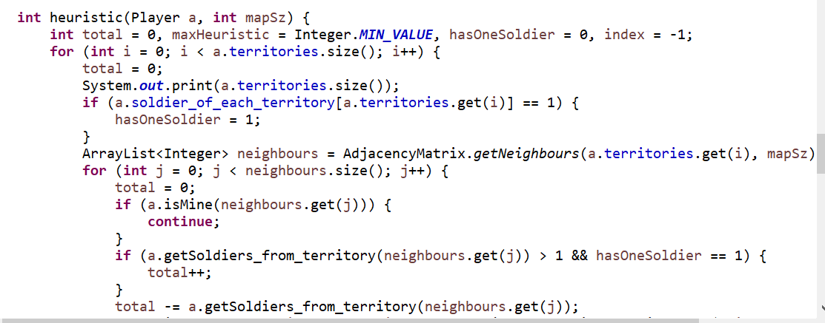

**A* agent:**

AggressiveVsAStar:

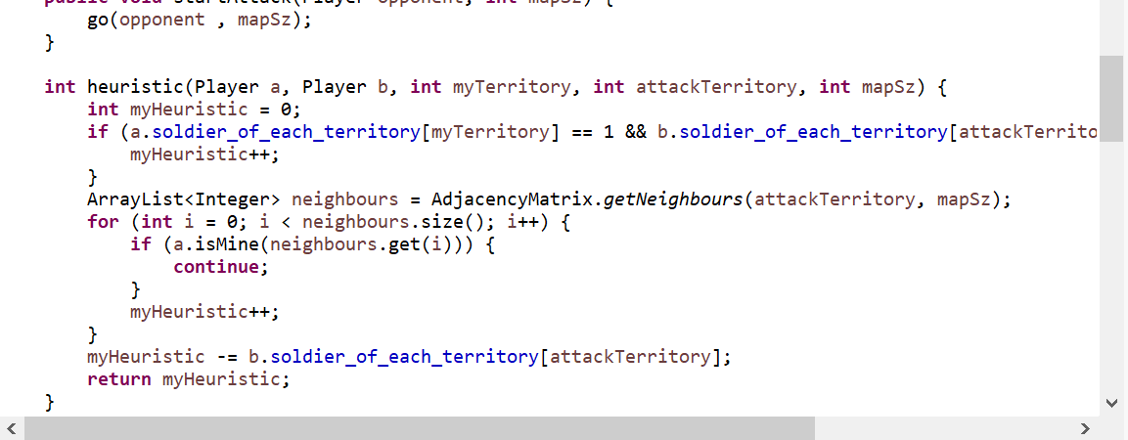

**RTA* agent:**

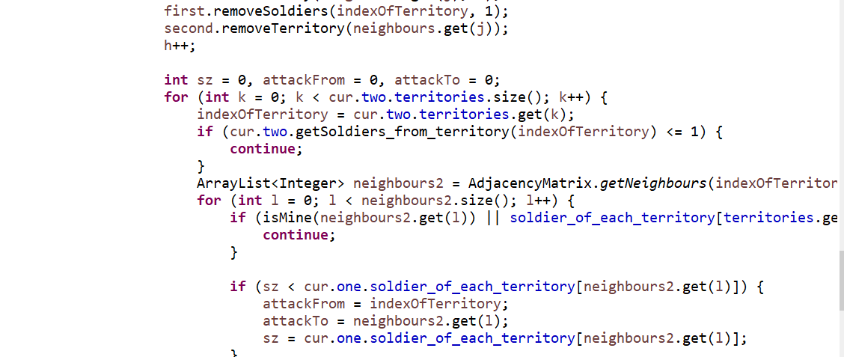

**Playing RTA*:**

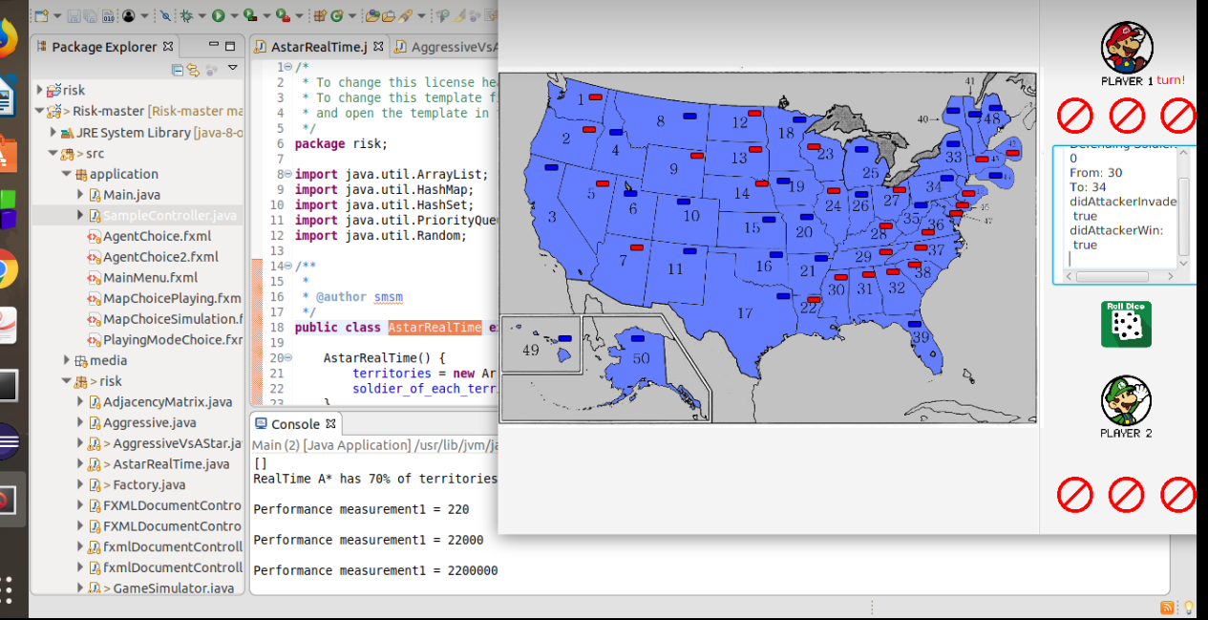

**Minimax agent:**

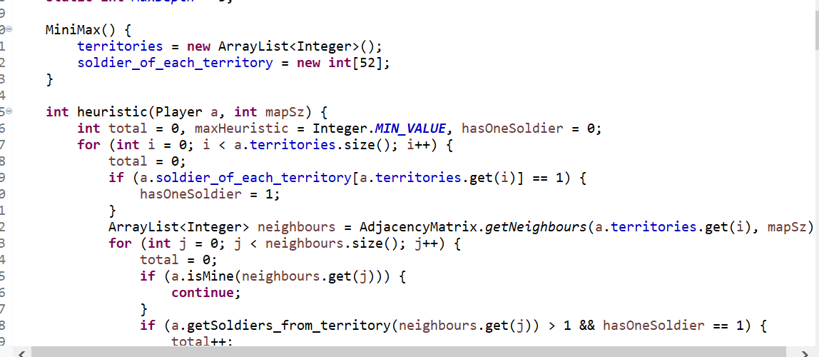

**Heuristic Used:**

1)NBSR: It gives a direct ratio of how the units could be distributed

Among countries.

2)territory that has fewest armies.

**Running:**

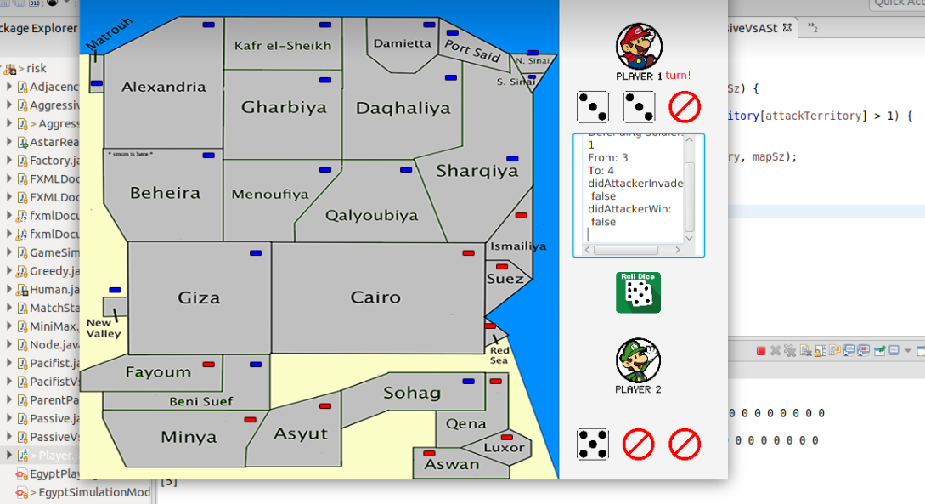

**Performance Measure:**

**Real-time A* performance Measure:**

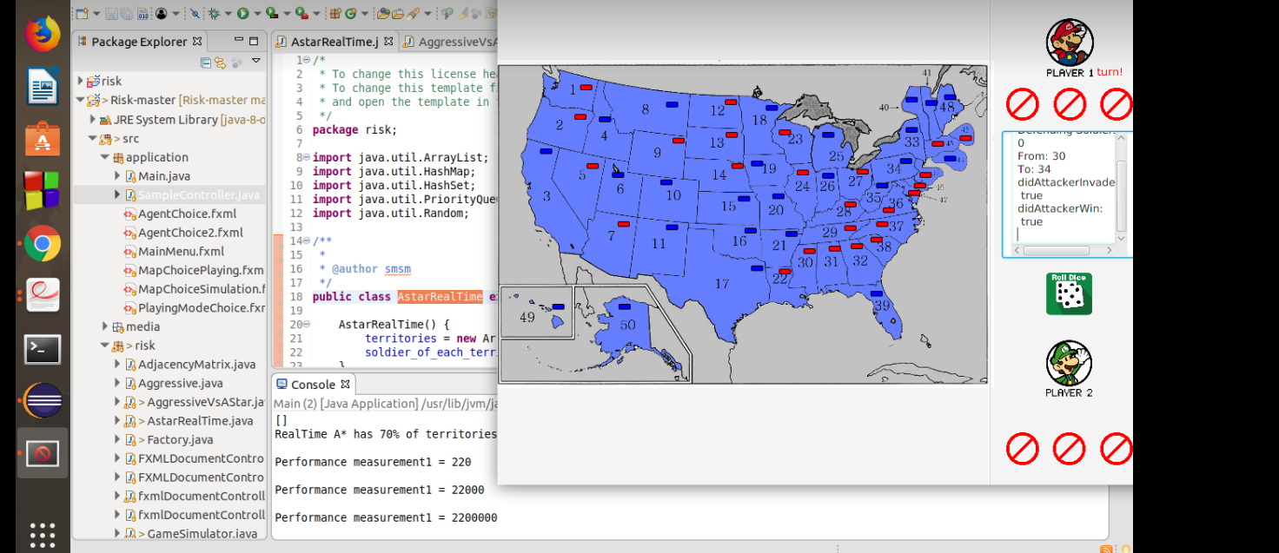

**A* performance Measure:** 